Learning is defined as a relatively permanent change in behavior or potential behavior that occurs as a result of experience, practice, or training within an organizational context.

Key Aspects of Learning in OB
- Change in Behavior: The essence of learning in OB is a noticeable change in an individual's actions or attitudes, which may be positive or negative and is observable through their behavior at work.
- Experience-Based: This change happens after a person is exposed to direct or indirect experiences, such as training sessions, work tasks, or interactions with peers.
- Permanence: Learning leads to knowledge or skills that are relatively long-lasting, distinguishing it from temporary changes caused by factors like fatigue or mood.
- Organizational Relevance: In OB, learning can modify employee performance, productivity, and adaptability. It encompasses individual, group, and organizational levels

Importance in Organizations
- Enhances individual and team performance.
- Supports organizational adaptation to change.
- Modifies behaviors to achieve strategic goals.
Learning in OB is a foundational process for shaping behavior, skills, and attitudes throughout an organization

The classical conditioning theory of learning is a process where a neutral stimulus becomes associated with a stimulus that naturally elicits a response, so that the neutral stimulus alone eventually triggers a similar response.

Key Elements of Classical Conditioning
- Unconditioned Stimulus (US): A stimulus that naturally and automatically triggers a response (e.g., food causing salivation in dog).
- Unconditioned Response (UR): The natural, unlearned reaction to the US (e.g., salivation in response to food).
- Conditioned Stimulus (CS): Previously neutral, it becomes associated with the US after repeated pairings (e.g., the sound of a bell).
- Conditioned Response (CR): The learned response to the previously neutral stimulus, now the CS (e.g., salivation in response to the bell).

Overview
- Discovered by Ivan Pavlov, classical conditioning is also known as Pavlovian conditioning.
- This theory shows how behaviors can be learned through association, forming the foundation for behaviorist psychology.
- It is distinct from operant conditioning, which is based on consequence rather than association.
Classical conditioning demonstrates how a learning process can be triggered unconsciously by linking two stimuli so that one predicts the other, modifying behavior without conscious thought.

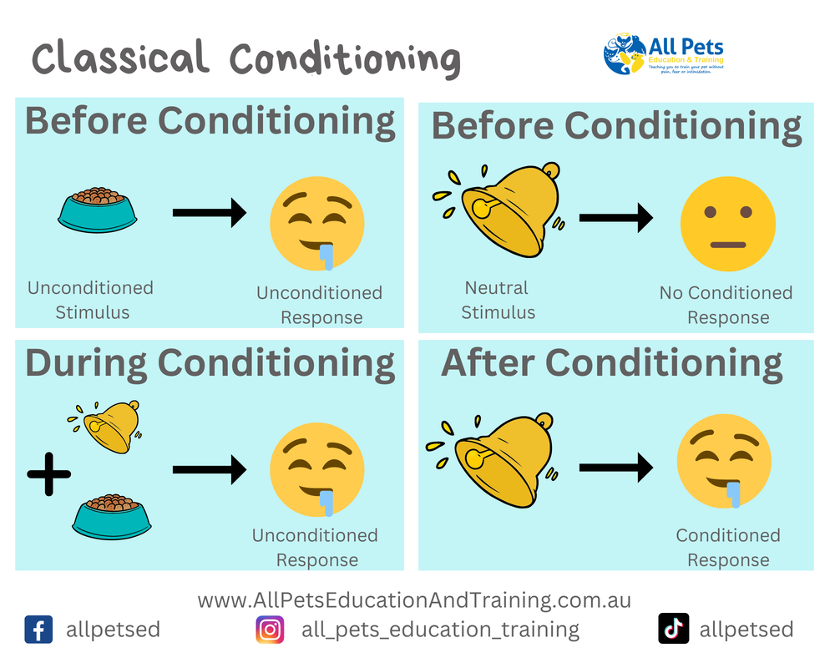

Real-world examples of classical conditioning in humans include everyday situations where behaviors or emotions are learned through association between stimuli.

Common Examples
- Phone Notifications: Hearing a familiar notification sound triggers an urge to check one’s phone, even when the sound belongs to another device. The notification tone (neutral stimulus) is repeatedly paired with receiving messages (natural stimulus), leading to a conditioned response.
- Advertising: Celebrities featured in advertisements create positive feelings; those emotions can transfer to the product itself. Seeing the product later can elicit feelings linked to the celebrity endorsement, even outside the ad’s context.
- Food Cravings: Smelling pizza or other favorite foods often produces salivation or hunger even before eating. Here, the food's aroma becomes a conditioned stimulus for the physiological response, like Pavlov’s original dog experiment.
- Childhood Experiences: A child walking past a house with a barking dog may develop a lasting fear of similar houses, or dogs in general, due to repeated pairing of anxiety with a specific situation.
- Report Card Emotions: Receiving a good report card is repeatedly paired with praise or rewards. Over time, the simple act of receiving a report card can evoke happy emotions before any feedback is given.

Additional Psychological Examples
- Phobias: After a traumatic event (e.g., a dog bite), simply seeing a dog or hearing barking can trigger fear—a learned, conditioned response.
- Taste Aversion: If someone gets sick after eating a new food, they may later feel nausea when encountering its taste—an example of aversion learned through classical conditioning.
- School Vaccination Anxiety: Children who see classmates cry after vaccination may associate needles with pain and feel anxiety when facing future injections.
- Music and Emotions: A particular song associated with a special event (e.g., meeting someone important) may evoke emotions related to that event whenever heard, even years later.
These examples show how classical conditioning shapes automatic reactions, emotions, and habits in daily human life through the repeated pairing of stimuli and responses

Classical conditioning has several pros and cons as a psychological learning theory, particularly when applied to human behavior.
Pros
- Behavior Modification: It effectively changes unwanted behaviors or develops new, positive ones through therapies like aversion therapy.
- Treatment of Phobias: Classical conditioning is widely used to treat phobias and anxiety disorders by altering the associations between stimuli and emotional responses.
- Supported by Science: The principles are backed by extensive laboratory research, allowing behaviors to be reliably conditioned and extinguished in controlled environments.
- Predictability: Enables individuals and therapists to predict behavioral outcomes based on environmental changes, aiding in behavior control.
Cons
- Limited Scope: Classical conditioning is mainly effective for involuntary, reflexive behaviors and does not explain complex human actions involving thought or choice.
- Overlooks Cognition: The theory doesn’t address the role of mental processes, like reasoning or memory, in learning; it is reductionist by focusing only on observable stimulus-response relationships.
- Biological Constraints: Not all associations are easily learned; innate biological predispositions influence which stimuli can be paired, limiting universal applicability.
- Ecological Validity: While highly effective in the lab, classical conditioning may be less consistent in real-world, natural settings due to conscious awareness or other learned behaviors disrupting conditioned responses.
- Potential Negative Outcomes: Conditioning can sometimes result in undesirable behaviors, such as phobias or emotional distress, if negative associations form inadvertently.
Classical conditioning is a powerful tool for understanding and shaping involuntary responses, but its limitations make it less useful for complex or voluntary human activities.

Operant conditioning is a learning process in which voluntary behaviors are influenced and modified by their consequences, such as rewards or punishments. In this theory, behaviors followed by positive outcomes are more likely to be repeated, while those followed by negative outcomes are less likely to occur.

In operant conditioning:
- The organism is active, making choices that lead to consequences.
- Consequences are used systematically to increase or decrease behavior through techniques like positive/negative reinforcement and punishment.
This method, developed by B.F. Skinner, underpins many behavior modification strategies in education, therapy, and training

The classic experiment in operant conditioning was conducted by B.F. Skinner using a device known as the Skinner Box (operant conditioning chamber).

Overview of the Skinner Box Experiment
A white rat pressing a button in an operant conditioning chamber
- Setup: Skinner placed a hungry rat or pigeon inside a box equipped with a lever (for rats) or a key (for pigeons).
- Process: When the animal accidentally pressed the lever or key, a food pellet would be dispensed as a reward—this acted as positive reinforcement.
- Learning: Over time, the animal learned to repeatedly perform the behavior (pressing the lever or key) to receive food, demonstrating that behavior is strengthened through reinforcement.
- Variation: Skinner also tested schedules of reinforcement and the use of punishment (like lights or shocks) to explore how different consequences affected the rate and persistence of the learned behavior.
This experiment clarified how voluntary actions can be increased or decreased based on their consequences, forming the foundation for modern behavior modification techniques in psychology, education, and training

Key points about operant conditioning:
- It involves active behavior where the individual operates on the environment to obtain desired results or avoid unpleasant outcomes.
- Developed by B.F. Skinner, it contrasts with classical conditioning by focusing on voluntary responses rather than automatic reflexes.
- Behaviors can be increased through reinforcement (positive or negative) and decreased through punishment.
- It is widely applied in behavior modification, education, therapy, and animal training.
Operant conditioning explains how consequences shape future behavior in a flexible and controllable way.

The four basic operant conditioning processes are:
- Positive Reinforcement: Adding a pleasant stimulus after a behavior to increase the likelihood of that behavior occurring again (e.g., giving a treat to a dog for sitting).
- Negative Reinforcement: Removing an unpleasant stimulus after a behavior to increase the likelihood of that behavior recurring (e.g., taking painkillers to remove pain, which increases the likelihood of taking painkillers again when in pain).
- Positive Punishment: Adding an unpleasant stimulus after a behavior to decrease the likelihood of the behavior happening again (e.g., giving a speeding ticket to discourage speeding).
- Negative Punishment: Removing a pleasant stimulus after a behavior to decrease the likelihood of that behavior (e.g., taking away a child's toy following misbehavior).
These four processes shape voluntary behaviors by their consequences, reinforcing or discouraging behaviors accordingly.

Here are real-world examples illustrating each of the four basic operant conditioning processes:
- Positive Reinforcement: An employee receives a bonus for meeting a sales target, increasing the likelihood they will work hard to achieve targets again.
- Negative Reinforcement: A driver fastens their seatbelt to stop the car’s annoying warning buzzer, making them more likely to buckle up in the future to avoid the noise.
- Positive Punishment: A child touches a hot stove and feels pain, reducing the chance they'll touch it again.
- Negative Punishment: A teenager loses their video game privileges after missing curfew, decreasing the likelihood of future curfew violations.
These examples demonstrate how rewards or consequences shape behavior by adding or removing stimuli to increase or decrease specific actions

The pros and cons of operant conditioning are as follows:
Pros
- Effective Behavior Modification: Operant conditioning is powerful for shaping and modifying voluntary behaviors, enabling precise control through reinforcement and punishment.
- Wide Applicability: Used in diverse settings such as education, parenting, therapy, animal training, and workplace management to encourage desired behaviors and reduce undesirable ones.
- Clear Cause-Effect Relationship: Provides a systematic way to understand how behaviors are influenced by consequences, making behavior predictable.
- Motivational Tool: Reinforcements can boost motivation and engagement by rewarding positive behavior, helping learners and employees improve performance.
- Scientific Basis: Supported by extensive empirical research validating its effectiveness and flexibility in modifying behavior.
Cons
- Overemphasis on External Control: Focuses heavily on external rewards and punishments, which can diminish intrinsic motivation and creativity over time.
- Ethical Concerns: Use of punishment can be controversial and potentially harmful if misapplied or overused, especially in institutional settings.
- Limited Scope for Complex Behavior: Not well suited for explaining behaviors driven by internal thoughts, emotions, or complex decision-making processes.
- Potential for Dependency: Individuals may become reliant on reinforcements to exhibit desired behavior, limiting the development of self-regulation.
- Unintended Consequences: Misapplication can lead to negative side effects such as fear, aggression, or avoidance behaviors.
Operant conditioning is a highly effective but sometimes ethically sensitive approach to influencing voluntary behavior and has important limitations regarding intrinsic motivation and complex behaviors.


